Name: ____________________________________________

12 Angry Men Essay Assignment

Choose one of the following:
- The 8th juror is the hero of the play.
- There are more irrational arguments for guilt made by the jurors than rational ones.
- Many facts in the boy’s case were based on human traits (such as memory, hearing and sight). Should someone’s word be enough to convict another person?
- The jury system is the most accurate way of administering justice.

Explain how the evidence, jurors’ statements, and logical fallacies contributed to your decision. This will be a 5 –paragraph essay. You may use the play; your logical fallacies chart and evidence chart; and any other notes or handouts you have. Your essay will be graded on the following:

Ideas/Organization (60 points)
Precise Claim: Thesis (10 points)
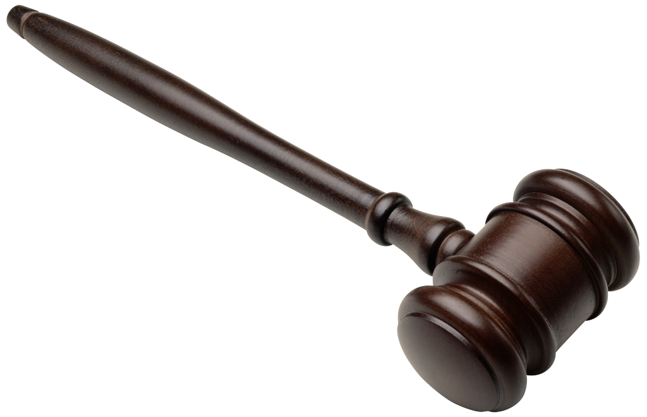
Topic Sentences, Transitions (10 points)
Evidence: valid, relevant, specific, sufficient (10 points)
Warrant/Assumptions/Explanations (20 points)
Conclusion (10 points)
Voice (20 points)
Word choice: formal, precise, appropriate (10 points)
Sentence Fluency: developed, cohesive, varied (10 points)
Conventions (20 points)
MLA: embedded and cited quotes (10 points)
Grammar does not interfere with meaning (10 points)

The rough draft for this essay will be due on_______________________________. You need three copies of your essay. If your essay is not in class that day, you cannot make up the point. This is the only assignment you MUST have with you in class. Please plan to be prepared.
The final draft of this essay is due on ______________________________________________. You need one copy of your rough draft with your final draft. You also need to earn at least an 70% on this essay to prove mastery of the topic. If you earn lower than an 70%, you will need to revise the essay.

I will not accept the excuse that your computer broke down, it froze, or your printer did not work. Use google docs to save it. . I will not be able to print for you, as my printer is nearly out of ink. Please plan ahead and print in the computer lab. Please plan ahead and be prepared. If you need to print in the computer lab during class, you will need to use an ultimate coupon.

