Ending the R-word: Ban it or understand it?
By Emanuella Grinberg, CNN
updated 11:19 AM EST, Wed March 7, 2012
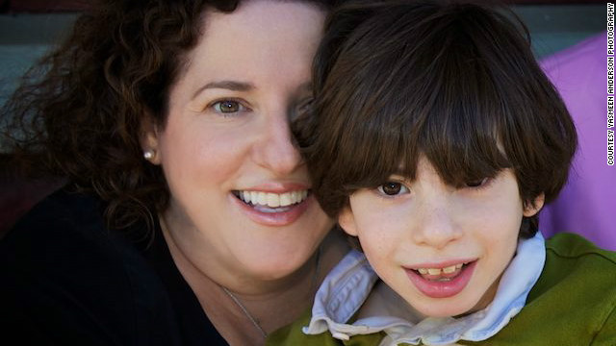
Ellen Seidman and her son Max, who has cerebral palsy.
(CNN) -- Every time Ellen Seidman hears the word "retarded," she worries for her 9-year-old son, Max, who has cerebral palsy.
She wonders if people will ever respect him, or see him as an equal, if they associate that word with people like him, who have intellectual disabilities.
"I'm not saying that anyone who uses the word flippantly has something against people with special needs," said Seidman, a magazine editor and mom blogger. "But it is a demeaning word even if it's meant as a joke, because it spreads the idea that people who are cognitively impaired are either stupid or losers."
Seidman is not alone in her desire to see "the R-word" go the way of racial slurs once considered acceptable. More than 250,000 people have pledged online to take part in the Special Olympics' campaign to "spread the word to end the word." Many of them are expected to participate in Wednesday's annual day of action through pledge drives, fundraisers and individual acts to raise awareness.
For her part, Seidman created a short video that explains what the word means to her. She posted it on her blog, Love That Max, and share it through social media. Although people who know her know where she stands (and not everyone agrees), she hopes that the video will make people think about the weight of the word.
"It starts with thinking about a word, but I want it to translate into the way people treat others with disabilities," she said. "It's about helping to see people with cognitive impairments as great people, as competent people, as people who can contribute in so many ways to our society."
Launched by two college students in 2009, the campaign is gaining traction not only among the citizenry, but in the halls of government and the medical community. President Obama passed Rosa's Law in 2010, which eliminates the use of the words "retarded" and "retardation" in federal health, education and labor laws.
The bill changed the terms "mental retardation" to "intellectual disability" and "mentally retarded individual" to "individual with an intellectual disability." This shift made the terms more consistent with language already used by the Centers for Disease Control and Prevention, the United Nations, and the White House. Currently, 43 states have passed similar legislation or have similar bills pending, according to the Special Olympics.
But policy is just one part of the strategy. The much larger goal targets social stigma and negative perceptions surrounding people with intellectual disabilities.
"You can't ban terminology any more than you can ban thought," said Dr. Stephen B. Corbin, senior vice president for community impact of the Special Olympics. "But we know that using bad language contributes to the dehumanization and stigmatization of others, which incites treating them differently."
On this point, some opponents of the movement agree with its supporters: Intellectual disability still carries a subconscious cultural taboo which attaches to the word used to describe it. But those who believe the movement is misguided and risky say the stigma will keep attaching to new terms until we purge negative connotations from the condition itself.
"All of this reflects the cycle of word taboo," said Christopher M. Fairman, a professor at the Moritz College of Law at Ohio State University and author of a book subtitled "Word Taboo and Protecting Our First Amendment Liberties." "We have witnessed this happen as the clinical diagnostic term 'mental retardation' became the offensive slur 'retard.' And so we will shift again, this time to intellectual disability."
Already, derogatory use of "ID" is starting to pop up, he said.
"By focusing on the word itself, you reinforce the negative connotation and actually strengthen the taboo," Fairman said. "The focus should be on the acceptance and inclusion of people with intellectual disabilities. This breaks down the cultural taboo that creates word taboo in the first place."
The idea of getting rid of negative perceptions is also at the top of Special Olympics' priorities. At the start of the millennium, Special Olympics President Tim Shriver began promoting the idea within the organization that stigma persists when the education system and media fail to release accurate messages about the population, Corbin said.
To get hard facts, the organization conducted a survey of 190 nations. Across all countries, more than one-third of the public believed that individuals with intellectual disabilities should work in special workshops, not in "mainstream" workplaces, the survey found. Worldwide, the vast majority of people believed that children with intellectual disabilities should be educated in special schools, separately from other children. A separate study of media portrayals determined that over time, depictions of persons with intellectual disabilities in film and TV focused more often on pity than on strength and achievements.
"Despite greater scientific knowledge, policy and societal changes, and the establishment of high-profile events such as the Special Olympics World Games, media accounts have continued to portray persons with intellectual disabilities in stereotypical, one-dimensional ways," said the authors of the study, which was released in 2005.
The organization's athletes began asking to change the language in Special Olympics policies, handbooks and literature to remove "mental retardation," which finally happened in 2004, Corbin said.
There are other signs that perceptions are changing for the better, he said. Project Unify, a partnership between the Department of Education and Special Olympics, lets special education students participate in team sports with general education teens. More than 2,000 schools in 42 states have unified athletic programs, with varying degrees of intensity. In the entertainment industry, actors like "Glee's" Lauren Potter are portraying characters with intellectual disabilities with depth and personality.
The push to cleanse the R-word from general conversation began to pick up speed in 2009, when two Special Olympics interns who were college students at the time decided to focus on the word. They engaged student leaders on college campuses to launch a day of action around pledge drives to stop using the word.
"There'd been plenty of movement within community to end the use word for years, but we decided we wanted student leaders to become the heart of the campaign," said Shriver, who was a Yale student at the time. "We recognized the pervasive use of the word among young people, but we also noticed an incredible desire among their peers to take on leadership roles and fight for the rights of people with ID."
More than 30 schools participated in the first day of action and each had its own approach, he said. Some students went classroom to classroom with posters for people to sign, others set up a fixed location with a table cloth for signing. From there, signees were directed to r-word.org for tips on how to respond to the word when it came up in casual conversation and how to drive a conversation about it.
"One of the things we wanted to do was really simplify and strip down this message and say, our goal is to educate about consequences and lead people to a point where they can reflect and decide for themselves," said Soeren Palumbo, an MBA student at the University of Pennsylvania who has a sister with intellectual disabilities.
"To force people to change their language and conceptions might be close to impossible, and we recognize that, because in the beginning we were not as nuanced. We thought could do that, and in the beginning we got a lot of backlash. But we can tell you about how using this language keeps up walls between people and dehumanizes people with ID."
Seidman, the mother who created the video on how the R-word affects her, admits she used to use it before Max was born.
"It's hard to explain until you experience it yourself, and I think a lot of people out there just don't understand why," she said. "There's already a lot of prejudice and misunderstanding about people with cognitive impairments, and this is one small thing I can do to help."

