Name____________________________ Date________ Per____

Illustrating Jim

- Who has the first line of dialogue in the novel? Why is that important?

- Which scenes do illustrators like to depict Jim in?

a.__________________________________________________________

b.__________________________________________________________

c.______________________ ____________________________________

2b. Why do you think they choose these scenes more than any other?

- Describe E.W. Kemble’s pictures of Jim. What are the things that stand out? What are some of the stereotypes seen in them?

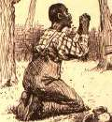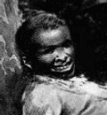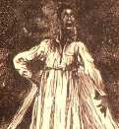

- Looking at the cover of Huck Finn Kemble drew, what do you notice about the placement of Jim? Who are the other two characters? What do you think each of them are doing?

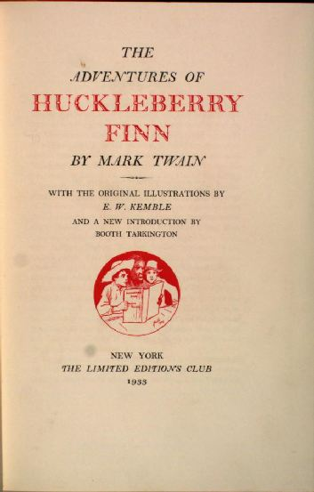

- What do you think Kemble’s opinion of Jim was?

- Look at Wroth Brehm’s picture of Jim? What characteristics about Jim have changed? Which have stayed the same?
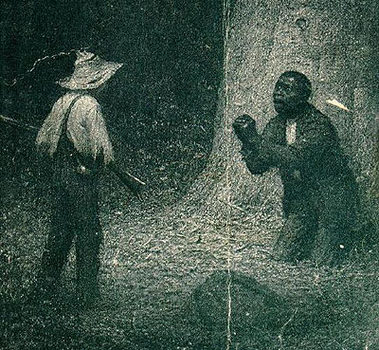

- What do you think Brehm’s opinion of Jim was?

- How is his opinion different from Kemble’s?

- Compare Rockwell’s pictures with the previous two artists’. What are similarities? What are some differences?

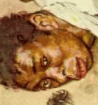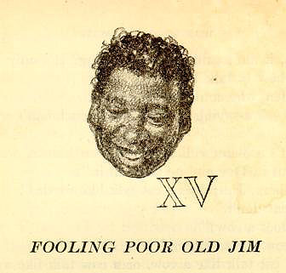

- Look at the McKay pictures. What makes these pictures different than previous?
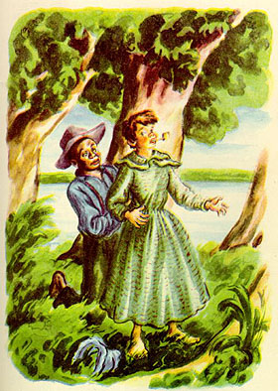
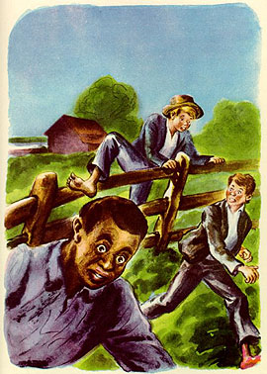

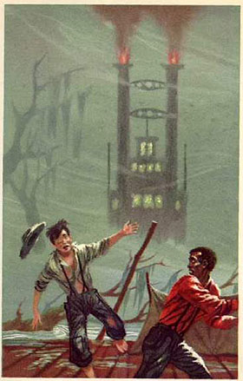
- What are some new characteristics seen in the Richard Powers picture?

- Have the John Falter pictures progressed or regressed in the depictions? How do you know?
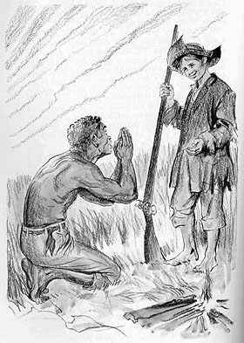
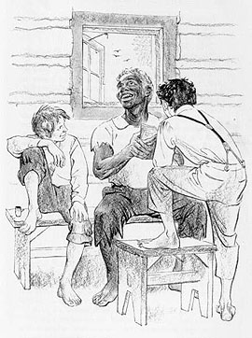

- What’s wrong with the cover picture here?

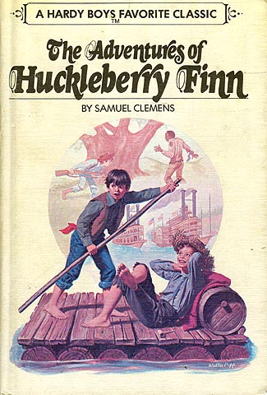

- Though both of the following pictures are the same artist and in the same edition, how are they different? How is Jim depicted differently in each one?

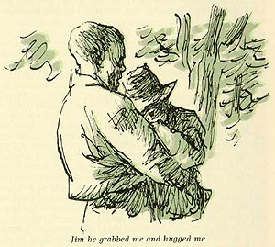
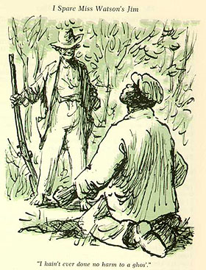

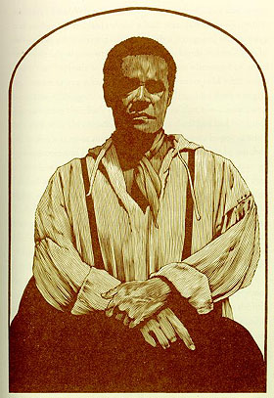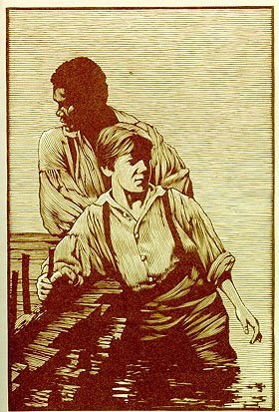

- Describe Moser’s pictures. How do they show Jim has changed over 100 years? How are they different from all the previous pictures?

- Describe Jim’s evolution over 100 years.

17. Which artist’s work most faithfully illustrates the novel’s text?

