Why Read?
“Literature is the most astonishing technological means that humans have created, and now practiced for thousands of years, to capture experience. For me the thrill of literature involves entering into the life worlds of others. I’m from a particular, constricted place in time, and I suddenly am part of a huge world— other times, other places, other inner lives that I otherwise would have no access to.”
Stephen Greenblatt, professor of Humanities at Harvard and author of the 2012 Pulitzer Prize winner for nonfiction, The Swerve: How the World Became Modern.

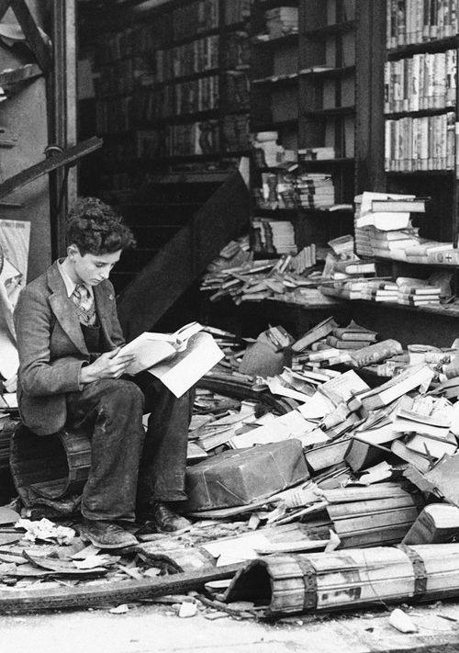
Boy reading in a bombed bookstore, London 1940

